Cost Centre Hierarchy

Below job needs to be triggered from control-M.

Control M Job : FMSGB_P_NZL_OIC_04AD
Run Control : NZL_ANZ_GEN_EXTR_CCO_D1

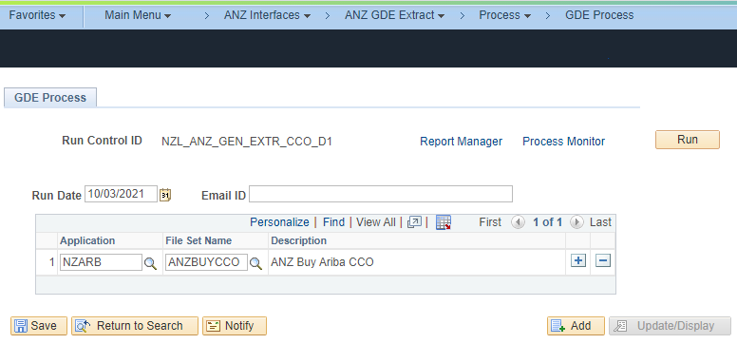
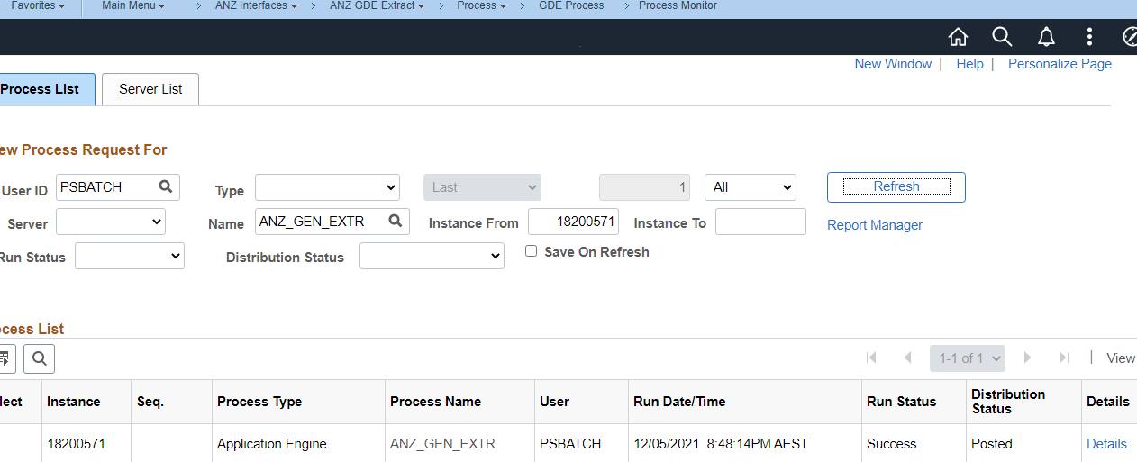
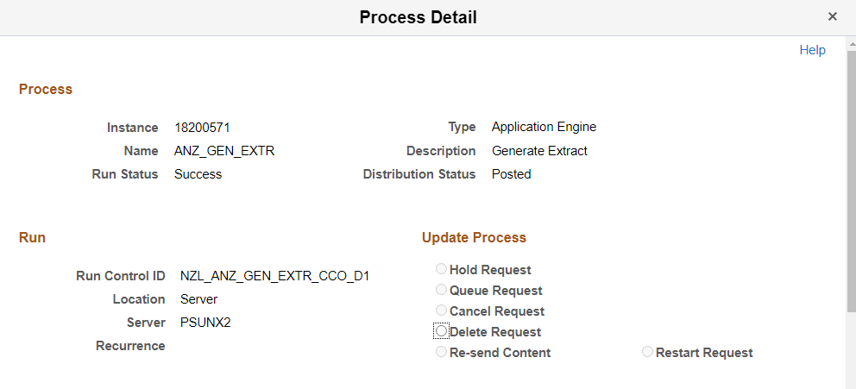
File generated in the specified NAS.
